CTM-I Use Case

Trading Group

Version 0.1

Use Case Name | Trading Group
Actor | Market Operations, Operations, App Support
Pre-conditions /Assumptions | User has Browser and is aware of the http path to the application.  User has successfully logged into the CTM-I application.  User has the right role to see the menu options.
Post Conditions | None
Screenshot | 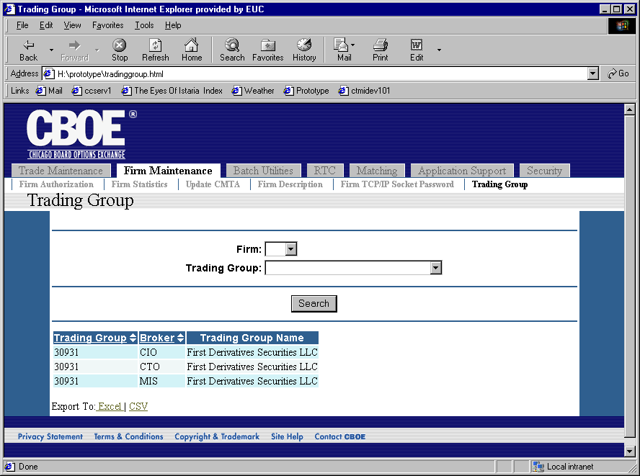
Flow of Events | - User selects “Trading Group” from the menu.  - The Trading Group screen is displayed.  - The first screen that displays only contains the Firm selection.  - Once the user selects the firm, the page is submitted and a request sent to CTM-R for the list of Trading Groups for the firm.  - The screen is re-displayed with the selected firm  - The list of trading groups for the firm is pre-populated in a selectable list. The display for the list should contain the trading group number and name. An option is available to the user to select “All”.  - The user presses the button “Search” to request the search to be processed.  - The search request is sent to CTM-R to process.  - The results of the CTM-R processing are displayed on the screen  - The results are displayed in a table with the following fields  - Trading group – sortable  - Broker – sortable  - Trading Group Name
Alternative Path | None

